**Project Report**

**Internet and Web Programming**

Stock Management System

Under Guidance of

Prof.Chokkalingam (SCSE)

Group Members

Kunwar Singh 12MSE1086

Abhiraj Singh 12MSE1037

Rajesh 12MSE1019

Abstract

Every Business who wants to be succesfull is changing its software system into ERP Software. ERP Software can benefit a company in various forms. ERP Modules consists of Financial Accounting , HR Management , Stock Management , Supplier Chain , Customer Relationship , Plant Maintenance , Employee Payroll etc. We are implementint Stock Management Module of ERP Software System for a Manufacturing Small Scale Industry. At the end of project we will show you Online Stock Management System.

Modules

**Module 1 Requirements and Design Phase**

* Analyzing the Problem and Designing Solution
* UML Diagrams – Usecase , Class , Component , Deployment etc
* Software Design Diagrams - JSP , JSP , SADT , SSA/SD
* Software Architecture – MVC Architecture Model

**Module 2** **Implementation** **Phase**

* In this we will code our project using MVC architecture.
* We will use html ,javascript ,jsp for presentation purpose.
* Java bean classes ,Servlets ,Filters for business logic.
* Hibernate Framework to map our classes to mysql database
* Strurts 2 framework to maintain mvc architecture

MVC Architecture

[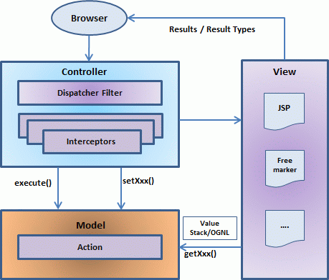](http://www.google.co.in/url?sa=i&source=images&cd=&cad=rja&uact=8&ved=0CAgQjRw&url=http://www.tutorialspoint.com/struts_2/struts_architecture.htm&ei=sO88VOTmBIKJuASipIGICQ&psig=AFQjCNGe3NOUftZYE72eM8rRdW62N3ZDzg&ust=1413366064163366)

MVC

Model -> Java Beans , POJO , Entity Classes , Struts Action Classes

View -> HTML , JSP , JavaScript , CSS , JQuery , AJAX

Controller - > Filters , Servlets

Software Tools

Netbeans 8.0 ,

Notepad ++

MySQL 5.4

Apache Tomcat Server

Framework

Struts 2

Hibernate 4